[11:00-11:10] Review of tune-up exercise and review from last lecture
Plotting a sinusoid in MATLAB may not produce a smooth plot. Increasing the sampling rate can help. When the sampling rates are low, discrete-time plots of sinusoids can be hard to recognize as sinusoids.
A time shift of a sinusoid results in a phase shift. We can calculate the phase shift from the time shift exactly, and we can use phase unwrapping algorithms to estimate the time shift from the phase shift.
The time shift/phase shift of a wave propagating through space can be used for navigation and ranging, including radio navigation and ranging (RADAR), and sound navigation and ranging (SONAR).
[11:10-11:20] Sound frequency and wavelength
The lowest audible sound is about 20 Hz. However, it is very difficult to produce a pure 20 Hz sinusoid, since it would require a large and powerful subwoofer.
Wavelength ($λ$, in meters) is related to frequency $(f$, in Hertz) by the speed of the wave ($c$, in meters per second):
$$λ=\frac{c}{f}$$
Speed of sound in air: 340 m/s
Speed of sound in water: 1500 m/s
Speed of light/radio waves: 3$×{10}^{8}$
To produce larger wavelengths, you need loudspeaker or antenna whose size is proportional to the wavelength. Example:
$$\frac{340 m/s}{20 Hz}=17m$$
To reproduce a sampled signal, we require the sampling rate $f_{s}>2f_{\max{ }}→f_{\max{ }}<\frac{1}{2}f_{s}$
[11:20-] Sampling
Many signals are initially measured as continuous signals (e.g. sound converted from continuous pressure signal to a continuous voltage signal via transducer)
Sampling a continuous signal at equally spaced intervals $T_{n}$ in time produces a discrete time signal:
$$\underset{discrete time signal}{\underbrace{y\left[n\right]}}=\underset{\begin{aligned}continuous signal evaluated at integer \\ multiples of the sampling period\end{aligned}}{\underbrace{y(nT_{s})}}$$
Example: sampling a sinusoid:
$$y\left(t\right)=A\cos\left(2πf_{0}t+ϕ\right)$$
$$y\left[n\right]=y\left(t\right){\left.​\right|}_{t=nT_{s}}=A\cos\left(\underset{{\hat{ω}}_{0}}{\underbrace{2πf_{0}T_{s}}}n+ϕ\right)$$
${\hat{ω}}_{0}=2πf_{0}T_{s}=\frac{2πf_{0}}{fs}$ is the discrete time frequency in units of radians per sample.
How small does $T_{s}$ need to be (or how high does $f_{s}$ need to be) to for an accurate plot?
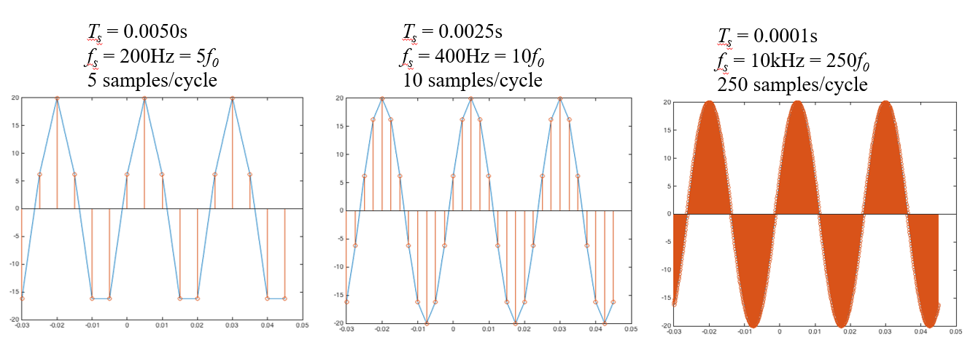
[11:35] Exponential signals
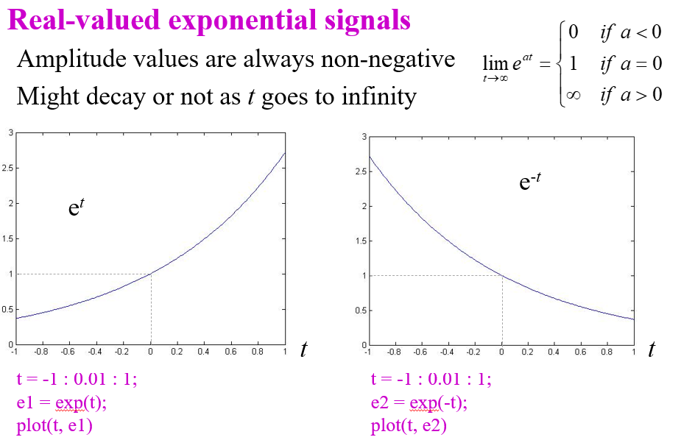
Complex exponentials are related to sinusoids:
$${e^{jθ}=\cos\left(θ\right)+j\sin\left(θ\right) \atop e^{-jθ}=\cos\left(θ\right)-j\sin\left(θ\right)}→{\cos{θ}=\frac{1}{2}\left(e^{jθ}+e^{-jθ}\right) \atop \sin{θ}=\frac{1}{2j}\left(e^{jθ}-e^{-jθ}\right)}$$
[11:45-12:15] Signal properties and spectrum representation
Signals can be defined or described in many ways:
- As a function (e.g. $\cos{(t)}$)
- As a sequence of numbers
- By its properties (e.g. symmetric)
- As a piecewise combination of other signals
Signals can be represented spectrally as a combination of sinusoids:
$$x\left(t\right)=A_{0}+\sum_{k=1}^{N}{A_{k}\cos\left(2πf_{k}t+ϕ_{k}\right)}=X_{0}+Re\left\{\sum_{k=1}^{N}{X_{k}e^{j2πf_{k}t}}\right\}$$
Where $A_{0}$ is a real-valued and $X_{0}=A_{0}$ and $X_{k}=A_{k}e^{jϕ_{k}}$
Example (slide 1-16)
$$x\left(t\right)=\cos\left(2π⋅440⋅t\right)$$
$$x\left(t\right)=\cos\left(A_{0}\right)+A_{1}\cos\left(2π⋅440⋅t\right)+A_{1}\cos\left(2π⋅880⋅t\right)$$
$$A_{0}$$ | 0
$$A_{1}$$ | 1 | $$A_{2}$$ | 0
$$f_{1}$$ | 440 Hz | $$f_{2}$$ | 880 Hz
$$ϕ_{1}$$ | 0 | $$ϕ_{2}$$ | 0

$$y\left(t\right)=x^{2}\left(t\right)=\cos^{2}\left(2π⋅440⋅t\right)=\frac{1}{2}+\frac{1}{2}\cos\left(2π⋅880⋅t\right)$$
$$A_{0}$$ | ½
$$A_{1}$$ | 1 | $$A_{2}$$ | 0.5
$$f_{1}$$ | 440 Hz | $$f_{2}$$ | 880 Hz
$$ϕ_{1}$$ | 0 | $$ϕ_{2}$$ | 0

Two sided spectrum:
$$x\left(t\right)=A_{0}+\sum_{k=1}^{N}{A_{k}\cos\left(2πf_{k}t+ϕ_{k}\right)}=X_{0}+\sum_{k=1}^{N}{\left\{\frac{X_{k}}{2}e^{j2πf_{k}t}+\frac{X_{k}^{*}}{2}e^{-j2πf_{k}t}\right\}}$$
Where $x_{k}=A_{k}e^{jϕ_{k}}$ and $X_{k}^{*}=A_{k}e^{-jϕ_{k}}$
Example:
$$x\left(t\right)=10+14\cos\left(200πt-\frac{π}{3}\right)+8\cos\left(500πt-\frac{π}{2}\right) \\ =10+7e^{\frac{-jπ}{3}}e^{j2π100t}+7e^{\frac{jπ}{3}}e^{-j2π100t}+4e^{\frac{jπ}{2}}e^{j2π250t}+4e^{\frac{-jπ}{2}}e^{-j2π250t}$$
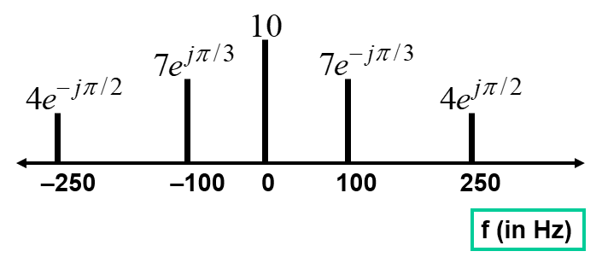
[12:15-] Beat Notes
When two sinusoids are multiplied, the result is two frequencies (sum and difference)
$$x\left(t\right)=\cos\left(2π10t\right)\cos\left(2π1000t\right) \\ =\frac{1}{2}\cos\left(2π 1010 t-\frac{π}{2}\right)+\frac{1}{2}\cos\left(2π 990 t-\frac{π}{2}\right)$$

Doc cam